**Sorting Algorithms**

**What is a sorting algorithms?**

Sorting algorithms are essential in computer science for arranging elements of a list or array in a specific order, such as numerical or alphabetical. Here are three commonly used sorting algorithms:

1. **Bubble Sort:**

* Bubble Sort repeatedly steps through the list, compares adjacent elements, and swaps them if they are in the wrong order. The pass through the list is repeated until the list is sorted.

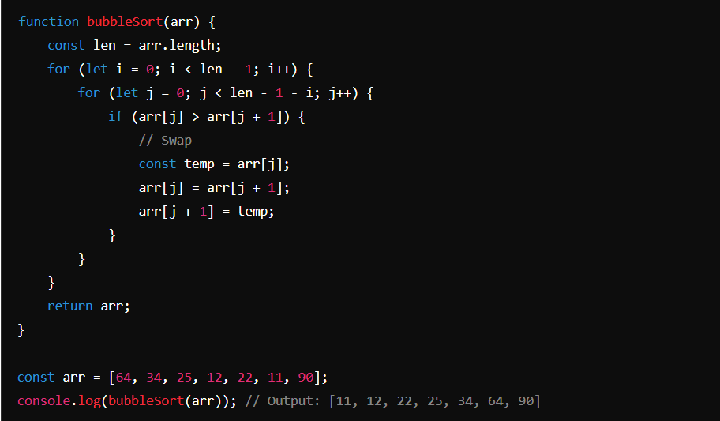

1. **Selection Sort:**

* Selection Sort sorts an array by repeatedly finding the minimum element from the unsorted part and putting it at the beginning. The algorithm maintains two subarrays: the sorted subarray and the unsorted subarray.

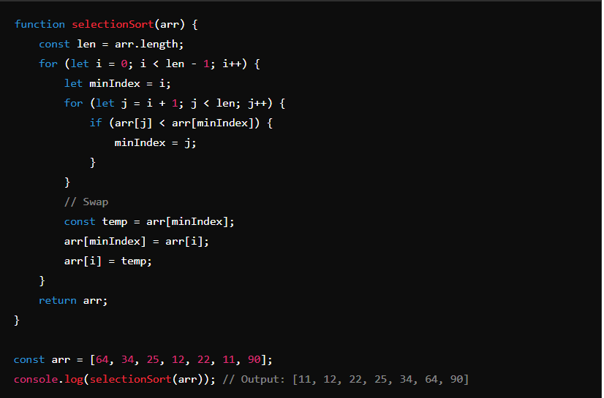

1. **Merge Sort:**

* Merge Sort is a divide-and-conquer algorithm that divides the input array into two halves, recursively sorts each half, and then merges the sorted halves.
* 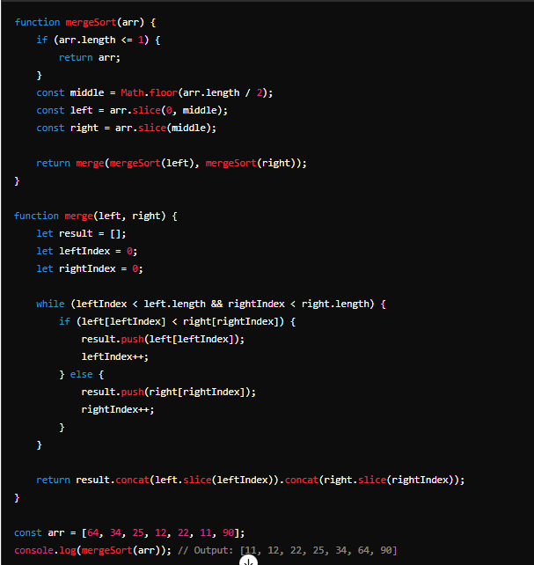

1. **Insertion Sort:**

* Insertion Sort builds the final sorted array one item at a time by comparing each element with the sorted portion of the array and inserting it into its correct position.

